Python Organizing Files from automated boring stuff with python

Notes

By

Jedsada LUENGARAMSUK

Contents

The shutil Module 3

Copying Files and Folders (shutil.copy) 3

shutil.copytree() 3

Moving and Renaming Files and Folders (shutil.move()) 4

Permanently Deleting Files and Folders (os ,shutil and send2trash) 4

Safe Deletes with the send2trash Module 5

Walking a Directory Tree(os.walk()) 6

Compressing Files with the zipfile Module 8

Reading ZIP Files 8

Extracting from ZIP Files 9

Creating and Adding to ZIP files 10

**Organizing Files**

- Copies pdf in every sub-folder

- Remove zeroes in filenames

- Compress several folders into on ZIP

# The shutil Module

- copy,move, rename and delete files

## Copying Files and Folders (shutil.copy)

- shutil.copy(source, destination)

- copy file at the path source to the destination (string)

#Copy spam.txt to delicious directory

#copy eggs.txt to delicious\\eggs2.txt ***Change file name to eggs2.txt

## shutil.copytree()

shutil.copytree(source,destination) > copy entire folder and every folder and file contained in it

## Moving and Renaming Files and Folders (shutil.move())

shutil.move(source,destination)





#The source file is move and rename



#bacon.txt is rename to eggs because there's no destination folder

## Permanently Deleting Files and Folders (os ,shutil and send2trash)

to delete single file or empty folders

os module is used

os.unlink(path) > delete file path

os.rmdir(path) < delete the folder at path

shutil.rmtree(path) > remove the folder at path, and all files and folders it contains

#Use for loop, if filename endswith .rxt, delete it

### Safe Deletes with the send2trash Module

- shutil.rmtree() = irreversibly deletes files and folders.

Dangerous to use

- send2trash > send folders and files to computer's trash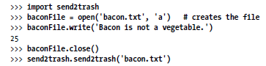

#send2trash.send2trash(file)

# Walking a Directory Tree(os.walk())

**- for rename every file and every subfolder of that folder**

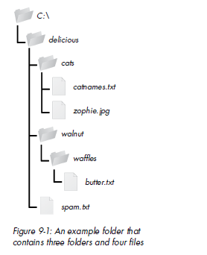

os.walk()

#Use loop statement to walk a directory tree

#range() functionn to walk over a range of numbers

#os.walk() will return 3 values

1. A string of the current folder's name

2.A list of strings of the folders in the current folder

3.. A list of strings of the files in the current folder

#os.walk() returns lists of strings for the subfolder and filename

# Compressing Files with the zipfile Module

- reduce size

- can contain multiple files and subfolders.

archive file

## Reading ZIP Files

1. Create a ZipFile object (zipfile.Zipfile(file))

2. Use method on the zipfile

#zipfile.namelist() > list content of this zipfile object

#fileobject.file_zize > fileobject.compress_size = find size

1.calculates efficiency of zip file

#zipfile is the same as file, you need to open and close.

## Extracting from ZIP Files

#zipfileobject.extractall() > extracts all the files and folders to current working directory

#or .extractall(path)

#zipfile.extract(file,path)

#This will extract a single file

## Creating and Adding to ZIP files

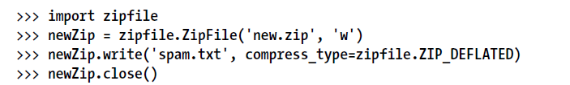

1. open Zipfile object with write mode

2. zipfile.write(file, compress_type)

compress_type is the type of algorithum

#This will create a new ZIP file name new.zip that has the compressed contents of spam.txt